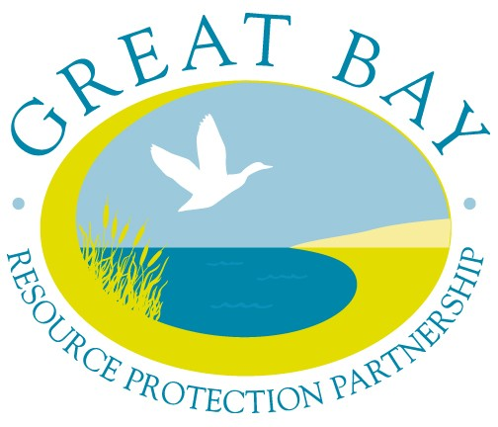

Great Bay Resource Protection Partnership

Land Protection Transaction Grant Program

April 2020

Grant Program Information & Application Instructions

~~~~~~~~~~~~~~~~~~~~~~~~~~~~~~~~~~~

- Grant Program Dates

Application Due Date: April 10, 2020 (postmarked)

The Great Bay Resource Protection Partnership (GBRPP) is offering matching grants to assist with land transaction costs for the permanent land protection projects in the Piscataqua Region coastal watershed area of New Hampshire and Maine.

B. Grant Program Information

I. Grant Guidelines and Program Options

- Eligibility
- Applicant. Qualified nonprofit tax-exempt 501(c)(3) conservation organizations or units of government may apply for a grant.

- Project. Permanent land protection projects, including the donation and/or acquisition of full fee and conservation easements.

- Geographic Eligibility. The property must be located wholly within the Piscataqua Region coastal watershed area of New Hampshire and Maine (see attached map and municipality list).

- Property Eligibility
See Section B Application Instructions and the Appendix Instructions: NH Coastal Viewer to Determine Project Eligibility for details on determining eligibility.
The property must coincide with at least one of the four priority conservation resource areas listed below. The application will be considered more competitive if the property includes more than one priority conservation resource area.
- Conservation Focus Area
- Tidal Water Shoreline
- Water Resource Conservation Focus Areas: Flood Storage and Risk Mitigation, Pollution Attenuation, and Public Water Supply
- Important Wildlife Habitat (Wildlife Action Plan, NH projects only)

While most projects that meet one or more of the eligibility criteria are eligible for funding, certain situations are generally not a good fit with the intent of the grant program. For example, easement agreements associated with permit requirements, projects involved in legal disputes, parcels with substantial contamination, or easements with dam maintenance provisions are examples of projects that are not considered a good fit for this program.

2. Grant Award Limits
For the Land Protection Transaction Grant Program April 2020 Grant round, an organization may be awarded up to $40,000, including the combined awards from Grant Program 1 (Appraisal) and Grant Program 2 (Completed Project). The maximum grant award for Grant Program 1 is $3,500 per property. The maximum grant award for Grant Program 2 is $20,000 per property. (See guidelines below for Grant Programs 1 and 2.) A separate application must be submitted for each conservation property.

3. Grant Program 1 Prospective Project Appraisals, up to $3,500 per project
The purpose of this Grant Program is to provide assistance with appraisal cost for projects where the applicant needs an appraisal to begin negotiations with the landowner or assess viability of a project. Completion or closing of the project is not required.
- Maximum grant amount: $3,500 per project or 50% of the appraisal cost, whichever is less.

- A minimum of one-to-one (1:1) match requirement for grant funds.
That is, an applicant must offer for appraisal costs at least $1 in match funds for every $1 of grant funds.

- Match funds may be from nonfederal or federal funding sources.

- Eligible reimbursable appraisal expenses must be incurred after 1/1/2020 and before 12/1/2020.

- Grant Program 2 Completed Project Transaction Costs, up to $20,000 per project
Grant funds awarded in Grant Program 2 may be used to reimburse transaction expenses of permanent land protection projects.

- Maximum grant amount: $20,000 per project.

- A minimum of one-to-one (1:1) match requirement for grant funds.
That is, an applicant must offer for transaction costs at least $1 in match funds for every $1 of grant funds. Applicants that provide a greater than 1:1 match ratio will receive priority funding status.

- Match funds may be from nonfederal or federal funding sources.

- Eligible projects should close after 4/10/2020 and by 12/1/2021

- Preference will be given to projects for which there is a contractual agreement in place such as a signed purchase and sale agreement or option agreement.

Grant Program 2 Eligible Grant Transaction Expenses:

- Expenses include Appraisal, Baseline Documentation Report, Environmental Hazard Assessment (Level I), Land Survey, Legal Fees, Recording Fees, Title Expenses.

- Expenses are reimbursable at the completion of the project.

- Expenses must be incurred after 4/10/2020 and before 12/1/2021.

Grant Program 2 Eligible Match Transaction Expenses:

- In addition to the eligible grant expenses listed above, the following are eligible match expenses: Professional Fees, Staff Time, Stewardship Endowment and other transaction-related expenses.

- Expenses may be incurred prior to 1/1/2020.

II. Grant Submission and Award Process

1. Application Form. The Applicant must complete an application form for each project and provide all the requested information.

2. Deadline. Applications must be postmarked by 3/6/2020. Applicants may hand deliver applications by appointment only (contact Dea Brickner-Wood, GBRPP).

3. Submission Requirements. Applicants must submit a total of five copies of each project application, including one original and four copies, and a CD or USB flash-drive including the application and property shape file.

4. Limits to Funding. In the April 2020 grant cycle, an organization may be awarded up to $40,000, including the combined awards from Grant Program 1 (Appraisal) and Grant Program 2 (Completed Project). The maximum grant award for Grant Program 1 is $3,500 per property. The maximum grant award for Grant Program 2 is $20,000 per property.

5. Award Process.
- Applicants will be notified by email of the receipt of their application. Applicants will be notified by mail of the award decision.

- Award decisions will be competitive in nature. Projects that meet more than one eligibility criteria, protect larger parcels of land, and/or provide higher ratios of match will rank most competitively.

- Only complete applications will be considered.

- Award decisions will be determined by a panel of Partnership conservation agency representatives.

III. Invoice Procedures

- Invoice template documents are available on the Partnership website: http://www.greatbaypartnership.org/grants.html

- All Grantees will be expected to submit one invoice per project, using the invoice template.

- Reimbursement of approved expenses will be issued to Grantees as a one-time lump sum.

- Invoices must include documentation (see below) of reimbursable Grant costs and Matching costs. Invoices will not be paid without this documentation.

- Grantees must retain on file receipts, timesheets, etc. that support reimbursable expenses in case of an audit, or if questioned.
Additional Invoicing Requirements:

Grant Program 1
- Provide documentation of appraisal cost (appraisal invoice, dated) and evidence of its completion (copy of appraisal cover letter, with signature).

- Submit invoice and documentation on or before 12/1/2020.

Grant Program 2
- Eligible transaction costs must have been expended, and all required invoicing documentation submitted on or before 12/1/2021, unless otherwise agreed upon.

- Documentation of expenditures to be reimbursed and funds claimed as match. Documentation may include a paid invoice for services, letter verifying receipt of stewardship endowment, letter verifying staff and / or volunteer hours, etc.

- Copies of the property closing settlement sheet and recorded deed and/or conservation easement.

- Other requirements as may be stated in the Grant Agreement.

IV. Match Guidance

Grant Program 1. A minimum of one-to-one (1:1) match requirement for grant funds.
The maximum grant award is $3,500 per project or 50% of the appraisal cost, whichever is less.

Grant Program 2. A minimum of one-to-one (1:1) match requirement for grant funds. That is, an applicant must offer for transaction costs at least $1 match for every $1 of grant funds. Funds may be federal or non-federal in origin. Additional match is encouraged. The applicant’s match contribution can be “cash” or “in-kind services” directly related to the project. Eligible match transaction costs are listed on the budget form.

In-kind services can be paid staff time or volunteer time, which is directly related to implementation of the project. Volunteer hours can be valued at the current rate for New Hampshire posted at http://www.independentsector.org/resource/the-value-of-volunteer-time/ Higher in-kind rates can be claimed if a person volunteered services in their professional capacity. In this case, the volunteer rate is the person’s “billable” rate for the service. The Grantee will be required to provide verification of employee and volunteer time that is claimed as match.

V. Grant Submission and Project Contact

Applications will be considered complete when all fields in the application are filled in and the mandatory maps have been included as attachments.

Applications must be postmarked by 3/6/2020. Applicants may hand deliver applications by appointment only (contact Dea Brickner-Wood, GBRPP).

Mail applications to: Dea Brickner-Wood
Great Bay Resource Protection Partnership
1 Colony Cove Road
Durham, NH 03824

For questions about this grant opportunity contact:
Dea Brickner-Wood ~ 603-868-6112 ~ info@greatbaypartnership.org

The Great Bay Resource Protection Partnership is a collaboration of conservation organizations in the coastal region that promotes landscape-scale land conservation and stewardship. Funding for the Land Protection Transaction Grant program is provided by the New Hampshire Charitable Foundation and the Thomas W. Haas Fund of New Hampshire Charitable Foundation. The Nature Conservancy serves as the fiscal agent for the GBRPP grant program. http://www.greatbaypartnership.org
- Application Instructions

- Contact Information and Applicant Certification
Provide property and contact information as requested, and certifying signature.

- Parcel Information
Provide information as requested for either Grant Program 1 or Grant Program 2.

- Eligibility Criteria

- Geographic Eligibility
The property must be located wholly within the Piscataqua Region coastal watershed area of New Hampshire and Maine (see attached map and municipality list).
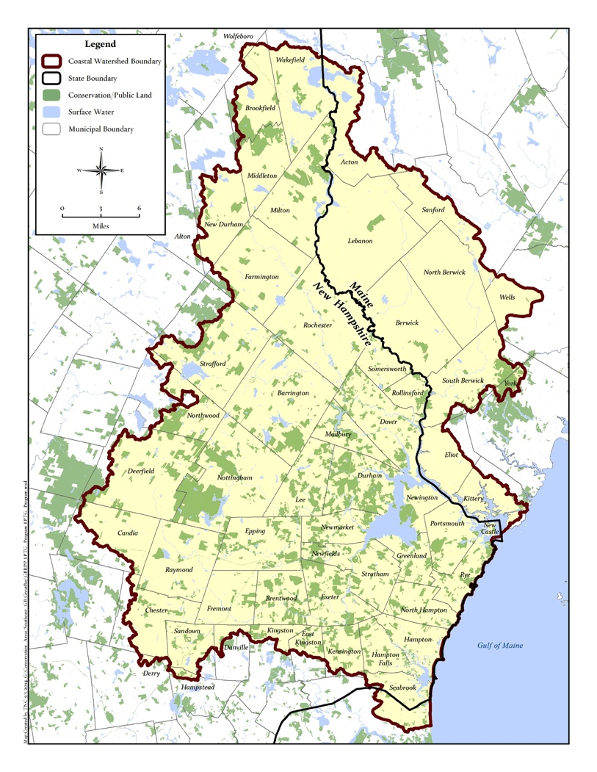

Municipalities
Acton
Barrington
Berwick
Brentwood
Brookfield
Candia
Chester
Danville
Deerfield
Dover
Durham
East Kingston
Eliot
Epping
Exeter
Farmington
Fremont
Greenland
Hampton
Hampton Falls
Kensington
Kingston
Kittery
Lebanon
Lee
Madbury
Middleton
Milton
New Castle
New Durham
Newfields
Newington
Newmarket
North Berwick
North Hampton
Northwood
Nottingham
Portsmouth
Raymond
Rochester
Rollinsford
Rye
Sandown
Sanford
Seabrook
Somersworth
South Berwick
Strafford
Stratham
Wakefield
Wells
York

- Property Eligibility
The property (or properties) to be protected must coincide with at least one of four (A through D) priority conservation resource areas listed below. In the application document, check all that apply and complete the relevant information fields. The application will be considered more competitive if the property(s) include more than one conservation priority. See the Appendix Instructions for using the New Hampshire Coastal Viewer to screen your project’s eligibility (includes criteria A., B., C. and D). Eligibility Criteria A and D website links provided below for reference.

- Conservation Focus Area
Provide the name of the Conservation Focus Area(s). If the property(s) is located in more than one CFA, list in order of greater to smallest acreage.

New Hampshire Applicants - Land Conservation Plan for New Hampshire’s Coastal Watersheds http://scholars.unh.edu/prep/174/

Maine Applicants - The Land Conservation Plan for Maine’s Piscataqua Region
http://scholars.unh.edu/prep/32/

- Tidal Water Shoreline
Includes shoreline on Great Bay, Little Bay, Hampton-Seabrook Estuary, or any tidal river or stream. Provide the water body name, and the length of water body frontage to be protected (sum linear footage of both sides).

- Water Resource Conservation Focus Areas: Flood Storage and Risk Mitigation, Pollution Attenuation, and Public Water Supply
The Water Resource Conservation Focus Areas for the coastal watershed identifies priority conservation areas that have the following attributes: Flood Storage and Risk Mitigation, Pollution Attenuation, and Public Water Supply, Tiers 1 and/or 2 (Land Conservation Priorities for the Protection of Coastal Water Resources. TNC, 2016).

- Important Wildlife Habitats – for New Hampshire Properties
The New Hampshire’s Wildlife Action Plan (2015) identifies priority conservation areas for the highest ranked habitat. Eligible areas are the WAP’s Highest Ranked Wildlife Habitat Map (Tier I & II) http://www.wildlife.state.nh.us/maps/wap.html

- Reimbursable Grant Transaction Expenses
Reimbursable Grant expenses to be incurred between 1/1/2020 to 12/1/2020 for Grant Program 1 and 1/1/2020 to 12/1/2021 for Grant Program 2 projects.

- Project Completion
Grant Program 1 Appraisal projects must be completed after 1/1/2020 and before 12/1/2020.
Grant Program 2 Conservation Projects must be completed after 3/6/2020 and before 12/1/2021.
Grant completion extensions may be requested and granted on a case by case basis.

- Maps
Provide the requested map information and maps for Grant Programs 1 and 2.
See Application Section IV Maps.

- Project Narrative

1. Grant Program 1. Provide the following information, adhering to word limits:

- Resource and Community Values (400 words or less)
Provide a concise description of the property.
- Type and quality of habitat.
- Water resource benefits, and shoreline, river and/or wetland buffers.
- Other conservation features and benefits.
- Connectivity with other permanently protected conservation lands.
- Community benefits and public access (if known).

- Prospective Project Circumstances (150 words or less)
Explain the circumstances and need/benefit for the appraisal for this prospective conservation property.

C. Property appraisal completion date.

- Grant Program 2

A. Resource and Community Values (500 words or less)
Provide a concise description of the property.
- Type and quality of habitat.
- Water resource benefits, and shoreline, river and/or wetland buffers.
- Other conservation features and benefits.
- Connectivity with other permanently protected conservation lands.
- Community benefits and public access.

B. Applicant, Partners, Stewardship (250 words or less)
Describe the following:
- Applicant capacity.
- Project partners.
- Strategy for long-term stewardship.

C. Project completion date (after property closing).

- Project Budget

Provide project budget information for Grant Program 1 and 2 as requested. The imbedded excel tables are formula-based for grant and match totals.

Appendix
Instructions: NH Coastal Viewer to Determine Project Eligibility

The New Hampshire Coastal Viewer is an online mapping tool with a geographic focus on New Hampshire’s coastal watershed communities. Specific data sets are available for Maine’s coastal watershed communities. The Coastal Viewer can be used to screen your project’s eligibility for this grant program. Note that the following instructions are based on the March 2018 version of the Coastal Viewer. Users should refer to guidance on the Coastal Viewer for updates that may be introduced in subsequent releases of the website.

A landing page on the Coastal Viewer was developed specifically to meet the screening needs of this program at http://nhcoastalviewer-lptg.unh.edu/. This page only displays the data layers that are relevant to the grant program’s eligibility; to view all the Coastal Viewer data layers use the dropdown on the left side of the screen under the “Layers” heading and select “All Layers”.

There are a variety of getting started and training resources for the Coastal Viewer at http://www.nhcoastalviewer.org/. If you are new to the Coastal Viewer please consider watching the 9-minute Get Started video, which will help you to understand how to use the application. Basic navigation of the viewer and its tools are described.

Data layers in the Coastal Viewer are organized by folders, some of which you need to drill down through (clicking the check box along the way to activate them) to get to the data layer that you want to view. Folders are differentiated in the list below by underlined headings, whereas data layers are shown in bold below. When you turn on a folder you are not turning on a viewable data layer, but rather enabling the viewing of a data layer within the folder; the data layer needs to be turned on to view it (and all folders it is within also need to be activated—this is a common pitfall and frustration for these types of applications).

When you open the Coastal Viewer using this link you will see the following structure of folders and data layers available for viewing in the “Layers” list on the left side of the screen:

Administrative and Political Boundaries This is the folder that contains available tax parcel data.
NH Parcel Mosaic
Polygons This is the tax parcel data available for most of the NH towns—not all NH towns are available.
Additional lines A small number of NH towns that are not represented in the “Polygons” data layer above have line-based tax parcels in this layer.
** Important note: both the “Polygons” and “Additional lines” data layers are scale-dependent. That is, you must zoom into your area of interest far enough for these layers to draw. If you are zoomed out too far the data layer heading is greyed out and the data layer will not draw.
Biology and Ecology
National Wetlands Inventory – Version 2
Referenced in eligibility criterion 2.B above for Tidal Water Shoreline. Mapping of this layer is available only for NH. ME Projects will need to verify eligibility using an alternative approach.
Once you are zoomed in to your area of interest (see Important note below), turn on this data layer. The layer will expand to show the colors of different wetland types displayed on the map. If your project overlaps or is adjacent to “Estuarine and Marine Deepwater” or “Estuarine and Marine Wetland” categories, your project is eligible. You can also use the identify feature tool from the “Home” toolbar tab (along the top of the map window) to click on a wetland area to identify its type. A table will pop up at the bottom of the screen (this might take a little time so please be patient). Look at the column under “NWI_TYPE”.
** Important note: “National Wetlands Inventory – Version 2” data layer is scale-dependent. That is, you must zoom into your area of interest far enough for this layer to draw. If you are zoomed out too far the data layer heading is greyed out and the data layer will not draw.
Environment and Conservation
Conservation and Public Lands This is the layer that is turned on when you open the Coastal Viewer.
Wildlife Action Plan Referenced in eligibility criterion 2.D above. Available for NH projects only.
Highest Ranked Wildlife Habitat
- Tier I is represented by purple as the “Highest Ranked Habitat in NH”

- Tier II is represented by green as “Highest Ranked Habitat in Region”

Land Conservation Plan Referenced in eligibility criterion 2.A above.
Conservation Focus Areas – 2006 (NH)
Conservation Focus Areas – 2010 (ME)
Water Resource Conservation Focus Areas 2016 Update Referenced in eligibility criterion 2.C above.
Flood Storage and Risk Mitigation
- Both Tier 1 and 2 areas are eligible.

Pollutant Attenuation
- Both Tier 1 and 2 areas are eligible.

Public Water Supply
- Both Tier 1 and 2 areas are eligible.

Single and Multi-Benefit Areas
- This is a compilation of the three preceding data layers that helps to understand how they overlap.
Base Maps/Aerial Imagery
There are many base map options to view aerial imagery. Regional coverages were collected for specific projects and have various geographic extents. For starters, you might consider using the Statewide theme and select the “NH 2015 1-foot RGB” data layer. RGB layers are 3-band color images (Red, Green, Blue), while the CIR layers are arranged in a color infrared composite of bands.

